Fleet Performance & Delivery Efficiency Dashboard

1. Data Cleaning & Modeling: ○ Fix missing fuel consumption values (use mean imputation).
○ Create a relationship using Vehicle_ID between Trip_Data and the Vehicle Master table.

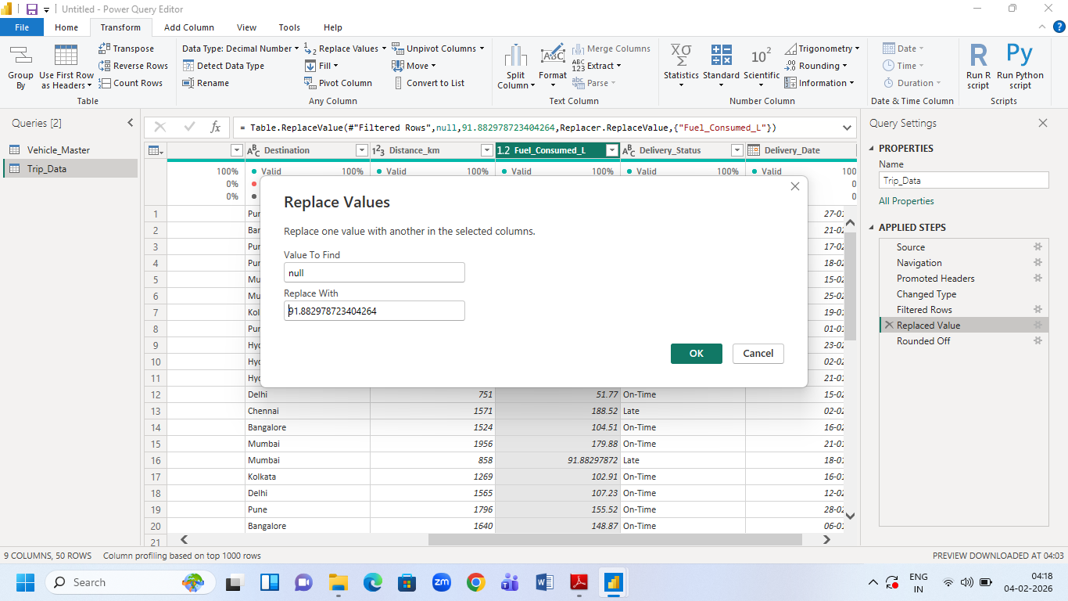
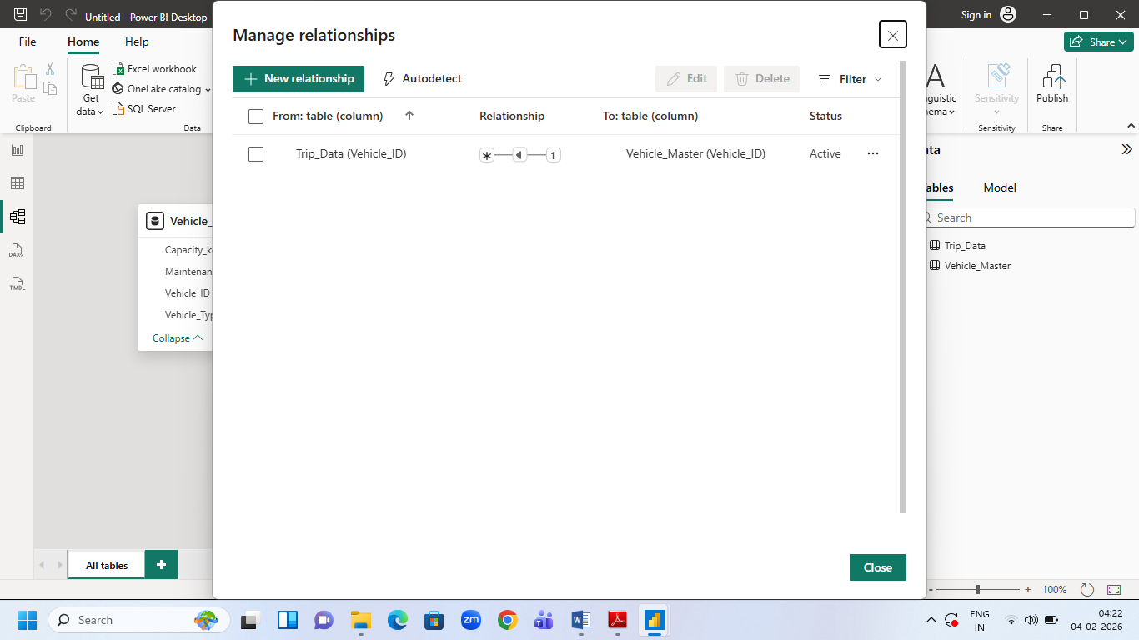
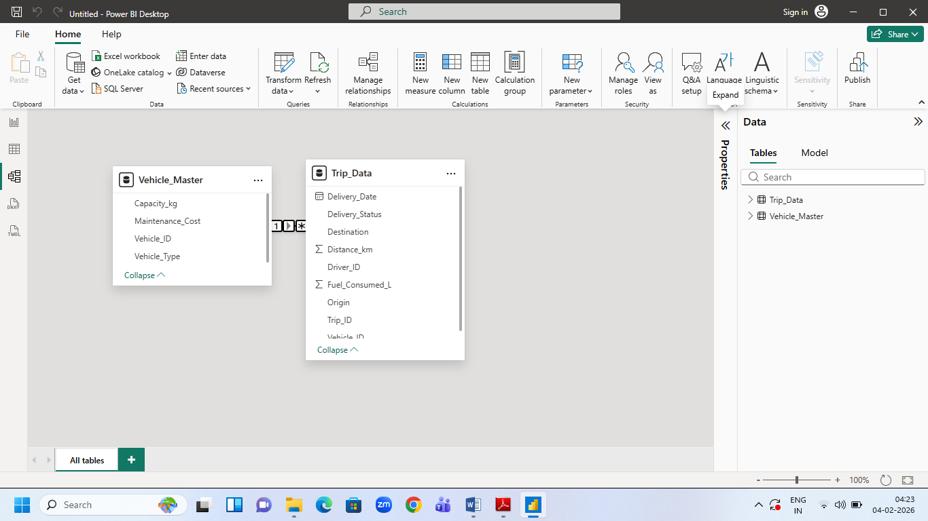

2. DAX Measures: ○ Fuel Efficiency = Distance / Fuel Consumed
○ On-Time Delivery % = On-Time Trips / Total Trips:

To do this, calculate the number of "On-Time" entries in the table and the total entries in the Trip_Data table, and then divide both results.
○ Cost per km = (fuel cost + Maintenance Cost) / Distance

Note fuel cost =100
Dax measures formulas:
1. Fuel Efficiency = DIVIDE(SUM('Trip_Data'[Distance_km]),SUM('Trip_Data'[Fuel_Consumed_L]))
2. On-Time-Trips = CALCULATE(count('Trip_Data'[Trip_ID]),'Trip_Data'[Delivery_Status]="On-Time")
3. Total-Trips = COUNT(Trip_Data[Trip_ID])
4. On-Time-Delivery % = DIVIDE([On-Time-Trips],[Total-Trips])
5. Cost per km =
DIVIDE(
[Fuel Cost] + [Total Maintenance Cost],
SUM('Trip_Data'[Distance_km])
)
6. Fuel Cost =
SUM('Trip_Data'[Fuel_Consumed_L]) * 100
7. Total Maintenance Cost =
SUM('Vehicle_Master'[Maintenance_Cost])

3. Visualization: ○ Bar chart: On-Time Delivery % by Destination.
○ Line chart: Fuel efficiency trend by delivery date.
○ Cards visualization: ■ Avg. Delivery Time
■ Average cost per km

1. Avg Delivery Time =
AVERAGE('Trip_Data'[Distance_km])

2. Average Cost per km =
AVERAGEX(
Trip_Data,
[Cost per km]
)

○ Pie chart: vehicle type vs Average maintenance cost

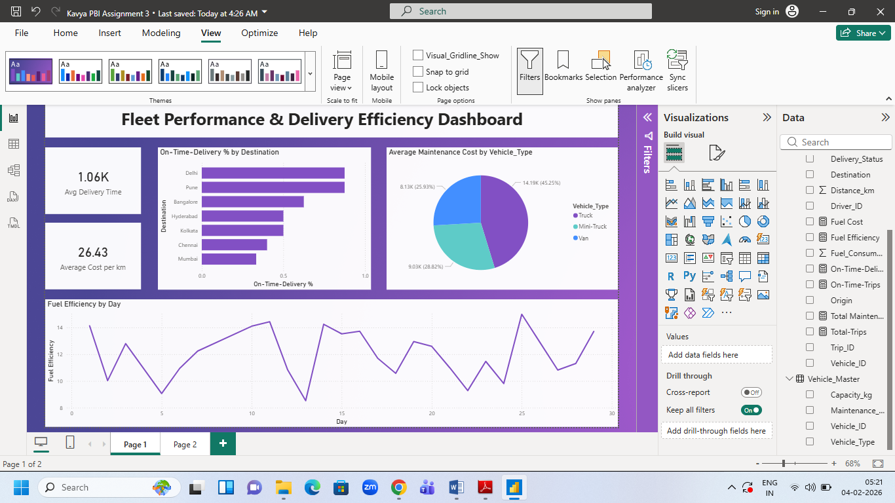

4. AI-Powered Visuals
❖ Q&A Visual: ➢ Add Q&A visual → Prompt: “Average Cost per km by vehicle type?”
❖ Key Influencers Visual: ➢ Add Delivery Status in the Analyze and explain by -distance in km,vehicle_type, Driver_ID
❖ Decomposition Tree (AI Visual): ➢ Analyze Cost per km → explained by Vehicle Type, Maintenance_cost, and Distance_km.
